Enhancement 3 – Databases
For this third enhancement, my plan included:
- Connect a functional database to the environment through MongoDB
- Add user information to log in so only logged in users can make edits to the table
The original artifact was from a dashboard/database project from CS340: Advanced Programming Concepts (Client Server Development). The purpose of the dashboard requested by Grazioso Salvare was designed to allow the user to filter and display data based on specific animal criteria from the Austin Animal Center. The developed dashboard included a filterable table, four filters, a dynamic map, and a pie chart that updated along with the selected filters.
I selected this item for this enhancement because I felt confident that it would showcase my ability to work with building and modifying a database, successfully connecting it to my site utilizing express and angular, adding a login page in which registered/authorized users can log in, and modifying the page so that a user must be logged in before they can edit the table.
I feel that I did meet the final course outcomes I had planned to meet for the third enhancement, “Develop a security mindset that anticipates adversarial exploits in software architecture and designs to expose potential vulnerabilities, mitigate design flaws, and ensure privacy and enhanced security of data and resources”. I was able to successfully connect a MongoDB database with 2 collections to the website (aac_animals & users), successfully perform the CRUD functions, and ensure that authentication and authorization processes were put in place so that only authorized users are able to modify database directly from the website.
I feel good about where this enhancement is and made some minor changes along the way that I hadn’t thought about prior to starting (like post form submission or button clicking routing.) The process of adding a user with tokens and authentication/authorization processes took a bit of time, but once I was able to follow previous guides regarding the details I missed (like adding a bearer token), I was able to get logged-in users actual access to add to the table.
(Original Dashboard Artifact)
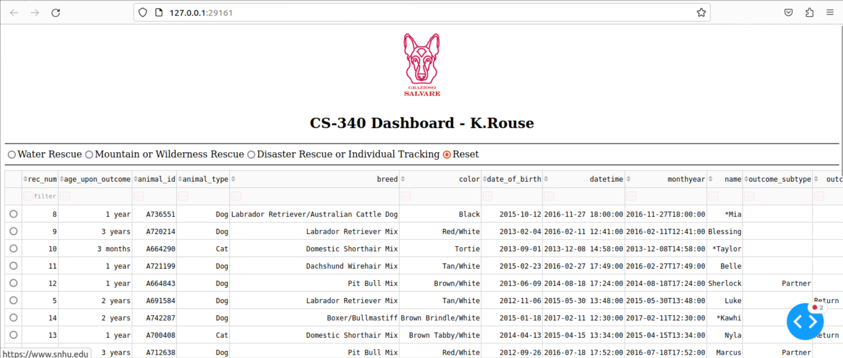
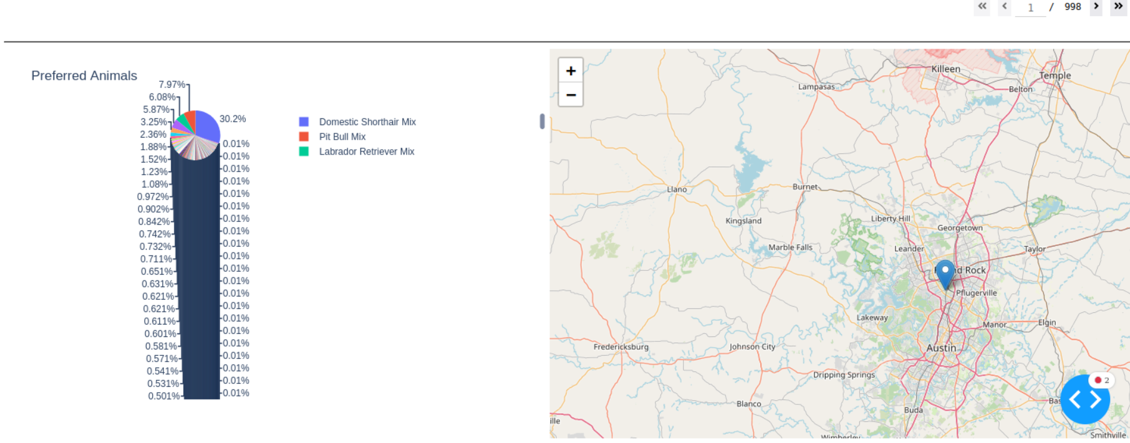

Austin Animal Center – Page anyone can see with login link
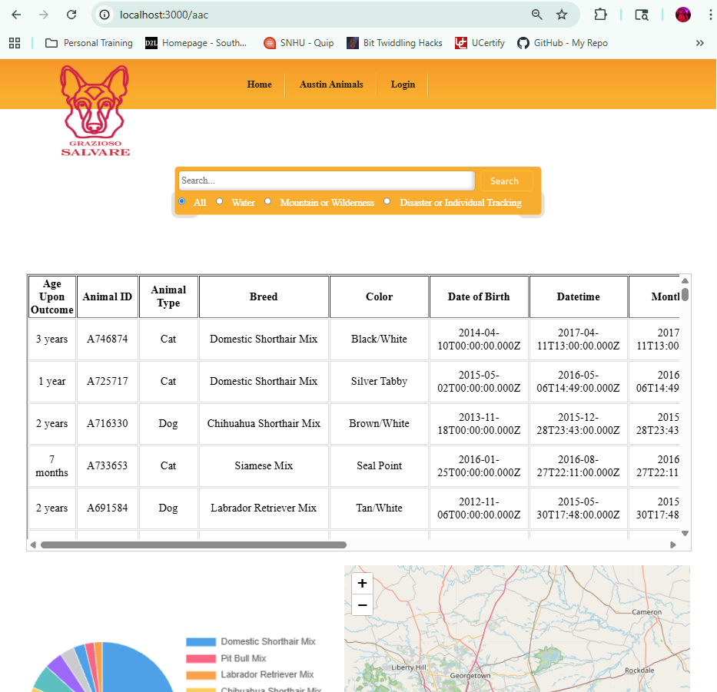

Goes to Login Page (I need to update 4200 to match stylesheet for 3000), but its functional currently
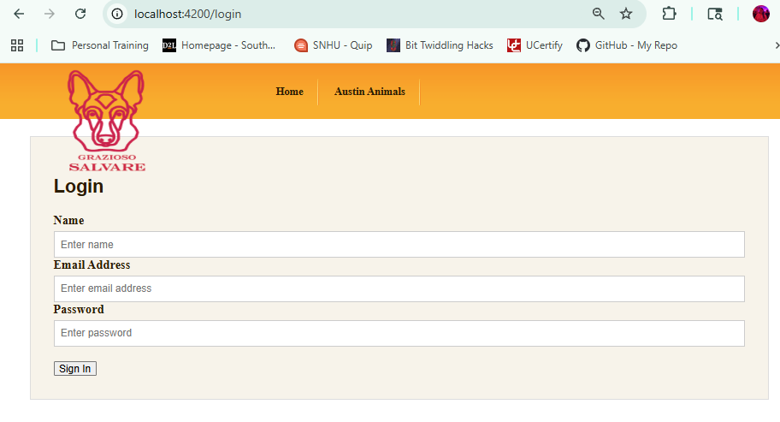
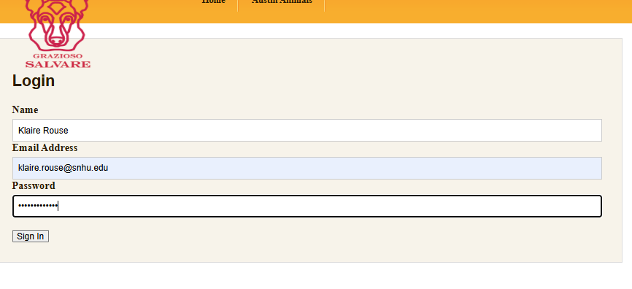

Once signed in, you now have admin (CRUD) buttons, and the login button now says logout (on both the aac & index pages)
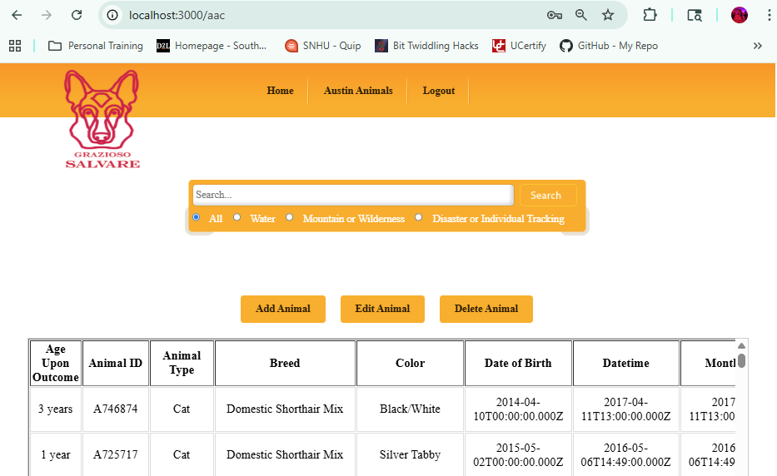
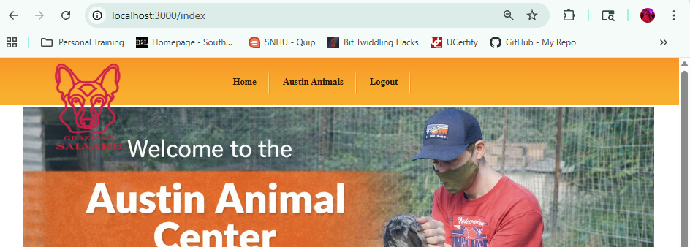

Successful additions of 2 tests in my MongoDB db aac_animals collection
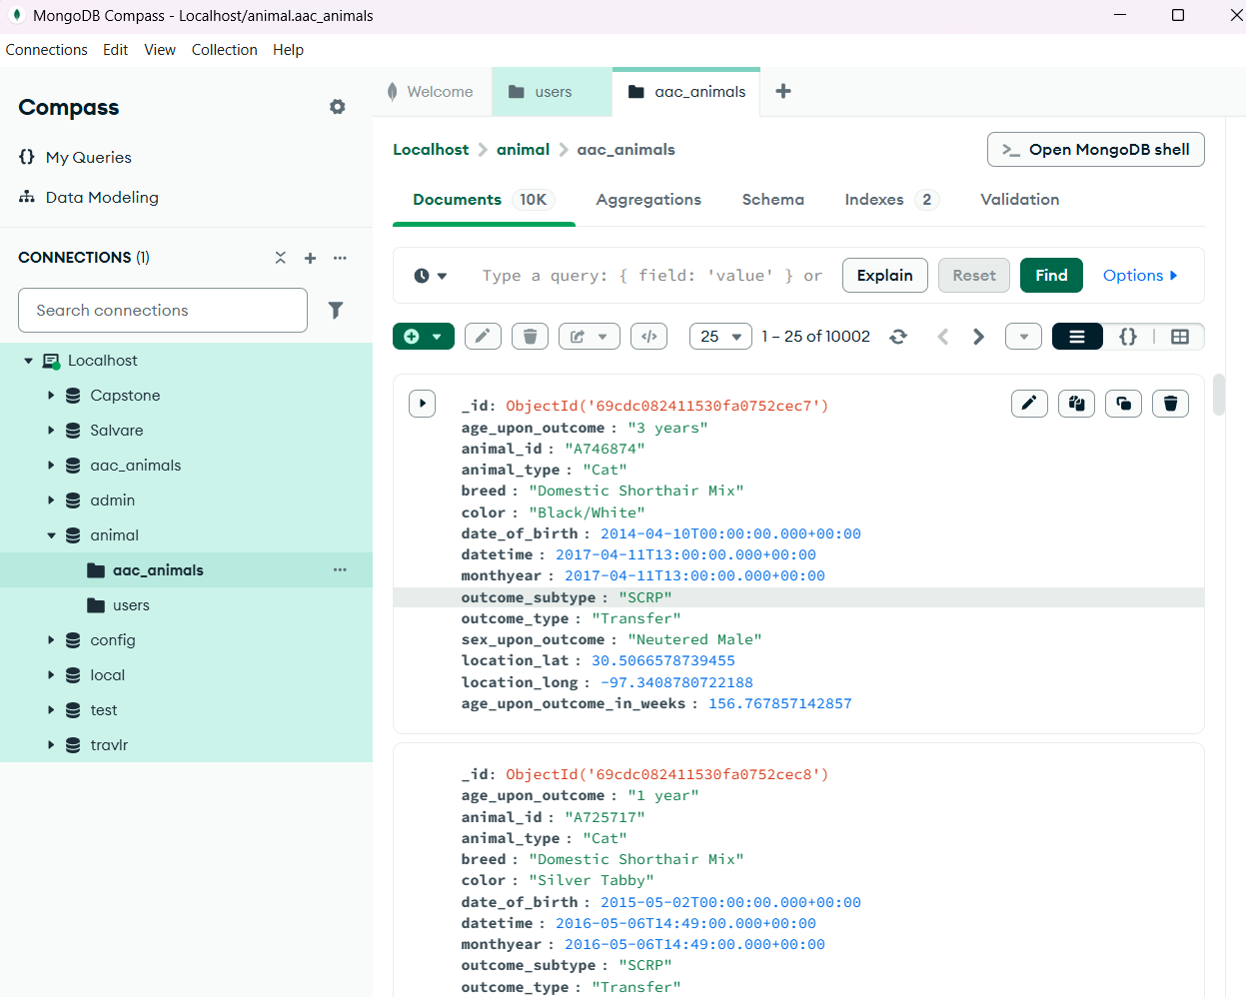

Successful creation of new users in the users collection that I can log in with.
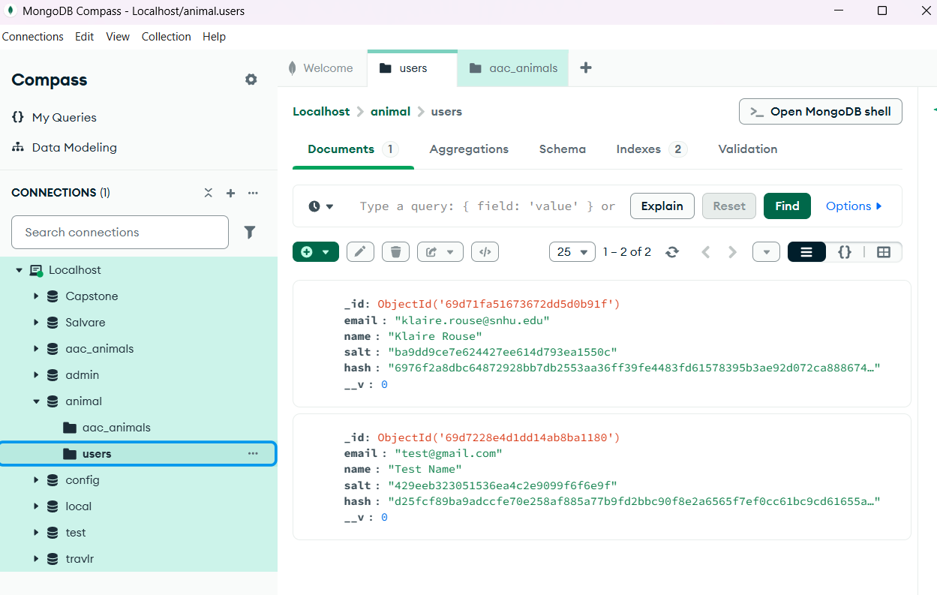

View of POST functionality for one of the “add animal” tests from the backend. The first example was from the online form.
